Dear Water Customer,
Section 17.12 of the Illinois Environmental Protection Act (415 ILCS 5/17.12) requires Community Water Supplies (CWS) to report a Water Service Line Material Inventory of service lines connected to distribution system water mains. A complete material inventory must be submitted by April 15, 2024. If an unknown substance is reported or the survey is not returned, the village will be required to identify your service line from the meter up to 18 inches inside your home.
The IEPA (Illinois Environmental Protection Agency) is requiring the Village of Millstadt to identify all water service lines in residential homes. To simplify the process, we are asking homeowners to confirm the type of waterline coming into the house and the year the home was built. We have provided pictures below for comparison.
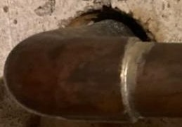
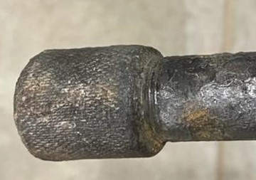
Copper □ Galvanized □
(Silver & threaded)

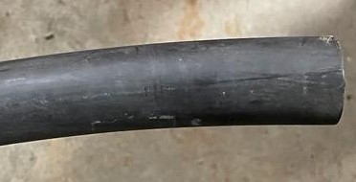

Plastic □
(black, blue or white)
Please check (X) the box that represents your waterline type above, sign, date and return to Village Hall by
August 15, 2023.

___________________________ ____________________________ ________________________________
NAME (PRINT) ADDRESS SIGNATURE

___________________________
YEAR HOME WAS BUILT

Thank you for your cooperation. If you have any questions, please contact Village Hall (618) 476-1514.

